ExploMeter

Introduction and Request for Comment

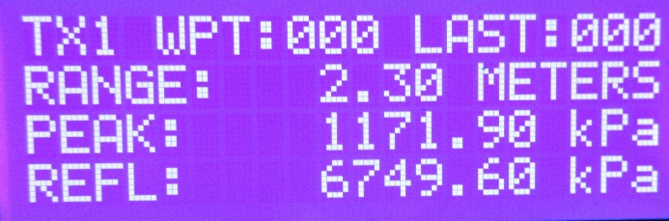
Function: ExploMeter® is being designed as a field instrument to indicate and record the expected pressure from an explosion. The type and quantity of explosive is entered into the RF transmitter which is placed where the ‘explosion’ is to occur. The receiver is positioned where required and a waypoint entered. The expected Peak Incident and Normally Reflected pressures are shown on the screen and recorded for later download. The receiver is moved, new waypoints entered and additional readings taken.
History: ExploMeter builds on Layer 3 Services’ patented RF “Hazard over Distance” technology. ‘ExploSim’ which shows blast and fragmentation injury and significant structural damage from explosions is already on the market, FragSim, FireSim and CBRSim are in development. The systems use WIFI (2.4 GHz).
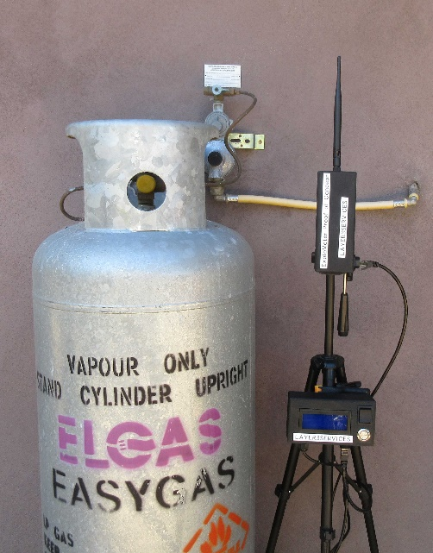
Safety: There are no energetic materials and the system is safe to use wherever WIFI is permitted.
Status: A ‘proof of concept’ model has been produced which is being exposed to the engineering and academic communities.
Request: We are seeking guidance, suggestions and technical input as we develop ExploMeter. All comments will be considered by the design team. All comments are non-attributable. We ask for contact details so we can seek clarification. Questionnaire attached.

For additional information please contact: services@layer3services.net.au

ExploMeter: comments, observations, suggestions?
Name:
Organisation:
E-mail:

Questions:
For what purposes could such a device be used?

Currently the digital readout provides: current waypoint, distance from transmitter, Peak Incident and Normally Reflected pressures. What additional information would be of benefit?

The downloadable Excel spreadsheet includes: time of event, explosive charge type and weight and well as waypoint and pressure results. What additional information would be of benefit?

It is intended the system will include a tripod and a ‘selfie stick’ to enable positioning of the receiver. Comments or suggestions?

Other observations or suggestions:

Please e-mail to services@layer3services.net.au .

