What use is an explosion in a box?

During one demonstration of the ExploSim system the comment was made “So, its basically an explosion in a box.”, we suppose it is.
So what use is an ‘explosion in a box’?

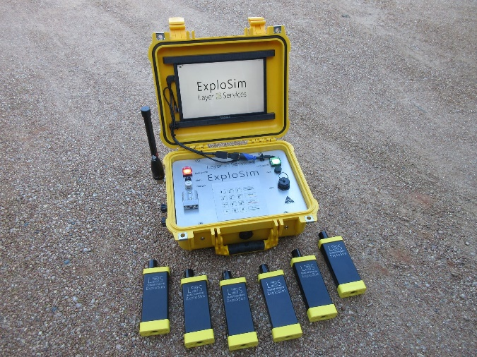
The ExploSim system allows users to see the effects of an explosion without causing those effects. It sends a coded RF signal to receivers to show if a receiver is in range of: a lethal blast pressure, blast injury, fragmentation injury or severe structural damage. ExploSim allows the user to select from 25 types of explosives and quantities from 100 grammes (~0.2 lb) to 20 tonnes (~44,000 lb) or from nine pre-programmed IEDs.
https://layer3services.net.au/explosim/

For Security, Safety and Emergency managers, building Wardens and Marshals the ability to fire off a range of explosions on site without interfering with normal operations enables:
- Testing of security measures such as access controls and stand-off distances:
  - What happens if a bomb explodes in this part of the site?
  - Given our current security measures, will a bomb damage or destroy critical elements of the business?
  - If our access controls allow only briefcases and handbags into this area what is the effect compared to having no bag size limits?
  - Our stand-off distance is ‘here’ so how big an explosion are we protected from?
  - What are the effects if a bomb explodes at this distance?
  - What if the bomb is bigger or smaller what if it is closer, further or to the side? With ExploSim any number of scenarios can be tried.
  - Can we detect a bomb near critical elements before it explodes? ExploSim has a built-in timer to allow practice of responses within time limits.
- Testing and validation of emergency procedures:
  - Are our emergency evacuations routes actually safe from possible bomb locations?
  - How effective are our bomb incident procedures (threats, unattended items, actual bombs)? Now we can test them against different bomb sizes.
  - How many casualties could be expected from a bomb of a certain size and location?
  - We can show the first aid responders what could be expected.
  - What severe structural damage could be expected from a bomb of a certain size and location?
  - We can replicate bombings that have happened in similar sites to see what might have happened here, without causing those effects.
- Pre-testing of planned security measures:
  - Will the proposed stand-off distances provide the protection required from the probable bomb sizes.
  - Will the procedures provide the expected level of protection.
  - Are certain walls going to need additional hardening and protection.
  - Based on ExploSim tests we know where to concentrate the detailed (and expensive) computer blast modelling.
- For Risk Managers:
  - Identify, test and rate vulnerabilities.
  - Test physical and procedural bomb incident risk mitigation treatments prior to implementation.
  - Validate bomb risk treatments currently in place.
  - Verify effectiveness of proposed solutions.
For Owners and Operators of Critical Infrastructure including entertainment and sports venues, utilities, transport hubs, ITC centres, Defence, Law Enforcement and related organisations, in addition to the security an emergency management uses above:
- Testing of current and planned security measures both business-as-usual and special events.
- Testing of business continuity plans in response to a bomb incident.
- Replicate bombings that have happened in similar sites, without causing casualties.
- Evaluate effects and responses while operations and business activities continue.
For Law Enforcement and Defence organisations, and others that provide EOD and IEDD and emergency support functions:
- The ability to train against explosives devices with immediate real-world indication of blast, fragmentation and structural effects.
- Train in any area where WiFi is permitted.
- Ability to test deployment distances for command and support teams.
- Ability to get immediate indication of effects from breaching and other explosive tools.
- Ability to test and validate First Responder responses to bomb incidents.
- Ability to immediately see the number of fatalities and injuries from an explosion.
For security, safety and blast consultants:
- Ability to demonstrate the effects of an explosion on site.
- Demonstration of the effectiveness of appropriate stand-off distances.
- Demonstration of the adequacy of existing or planned security and emergency management procedures.
- Cost effective multiple scenarios on site leading to focusing CFD modelling effort where it is of most value to the client.
For academics:
- The ability to educate students on energetic materials in a safe manner without requiring access to range areas and explosives.
- The ability to demonstrate the effects of blast in a classroom environment.
- As ExploSim is based on Kingerly Bulmarsh formulae the ability to task students to determine other factors such as impulse based on observed effects and distances.
For other users:
- We are certain there are many other uses for an ‘explosion in a box’ that will be come apparent. We look forward to working with users to develop them.

For more on the ExploSim system contact us at: services@layer3services.net.au
www.youtube.com/channel/UC5FwE9SxHUNFx2d0kmvPEMg
http://www.linkedin.com/company/layer3services

